20. Implementing Distributed Database System and Handling Data Partitioning.
CREATE DATABASE:-
CREATE DATABASE college;
USE college;
CREATE TABLE student(
student_id INT PRIMARY KEY,
name VARCHAR(50),
city VARCHAR(50),
department VARCHAR(50));
CREATE TABLES:-
CREATE TABLE course(
cource_id INT PRIMARY KEY,
cource_name VARCHAR(50),
credits INT);
INSERT SAMPLE DATA:-
INSERT INTO student VALUES
(1,'Rahul','Mumbai','Computer Science'),
(2,'Amit','Delhi','Mathematics'),
(3,'Priya','Mumbai','Physics'),
(4,'Neha','Delhi','Computer Science');
HORIZANTAL PARTITIONING:-
CREATE TABLE student_Mumbai AS
SELECT*FROM student
WHERE city='Mumbai';
CREATE TABLE student_Delhi AS
SELECT* FROM student
WHERE city='Delhi';
VERTICAL PARTITIONING:-
CREATE TABLE student_personal As
SELECT student_id,name,city
FROM student;
CREATE TABLE student_Academic AS
SELECT student_id,department
FROM student;
CHECK STORAGE ENGINES:-
SHOW ENGINES;
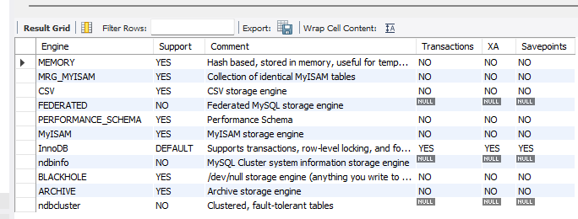
COMBINE HORIZANTALLY PARTITIONED TABLES:-
SELECT *FROM student_Mumbai
UNION
SELECT* FROM student_Delhi;
